### Homework 11

Problem 1:

% Define the differential equation

dydt = @(t, y) 20 * cos(5 * t) + 8;

% Define the initial condition

y0 = 10;

% Define the time span

tspan = [0 5];

% Solve the differential equation

[t, y] = ode45(dydt, tspan, y0);

t_value = 2;

y_value = interp1(t, y, t_value);

% Plot the time response

plot(t, y);

xlabel('Time (t)');

ylabel('y(t)');

title('Time Response of y(t)');

grid on;

% Find the value of y(t) for t=2 sec

y_value_at_t = interp1(t, y, 2)

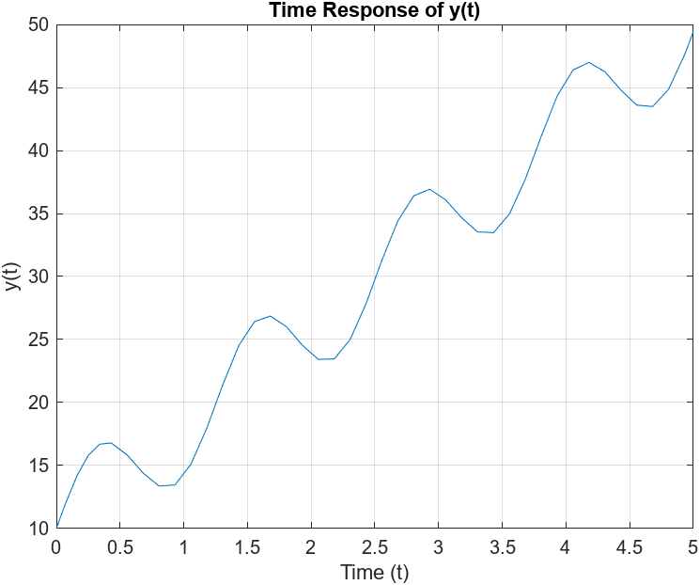

y_value_at_t = 23.9209

Problem 2:

% Define the differential equation

dydt = @(t, y) -50 * y;

% Define the initial condition

y0 = 20;

% Define the time span

tspan = [0 0.2];

% Solve the differential equation

[t, y] = ode45(dydt, tspan, y0);

% Plot the time response

plot(t, y);

xlabel('Time (t)');

ylabel('y(t)');

title('Time Response of y(t)');

axis([0 0.2 0 20]);

grid on;

% Find the value of y(t) for t=0.02 sec

y_value_at_t = interp1(t, y, 0.02)

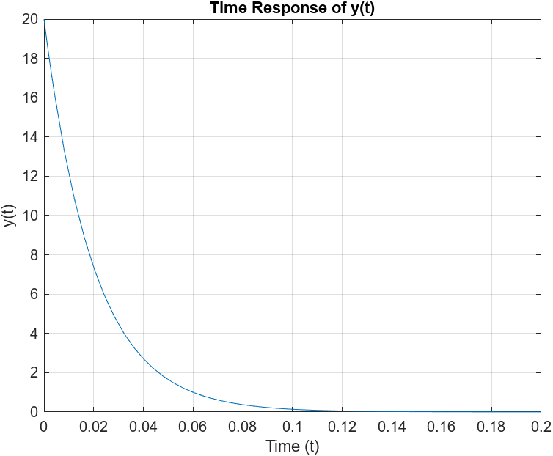

y_value_at_t = 7.3753

Problem 3:

% Define the differential equation

dydt = @(t, y) 400 - 50 * y;

% Define the initial condition

y0 = 20;

% Define the time span

tspan = [0 0.2];

% Solve the differential equation

[t, y] = ode45(dydt, tspan, y0);

% Plot the time response

plot(t, y);

xlabel('Time (t)');

ylabel('y(t)');

title('Time Response of y(t)');

axis([0 0.2 0 20]);

grid on;

% Find the value of y(t) for t=0.02 sec

y_value_at_t = interp1(t, y, 0.001)

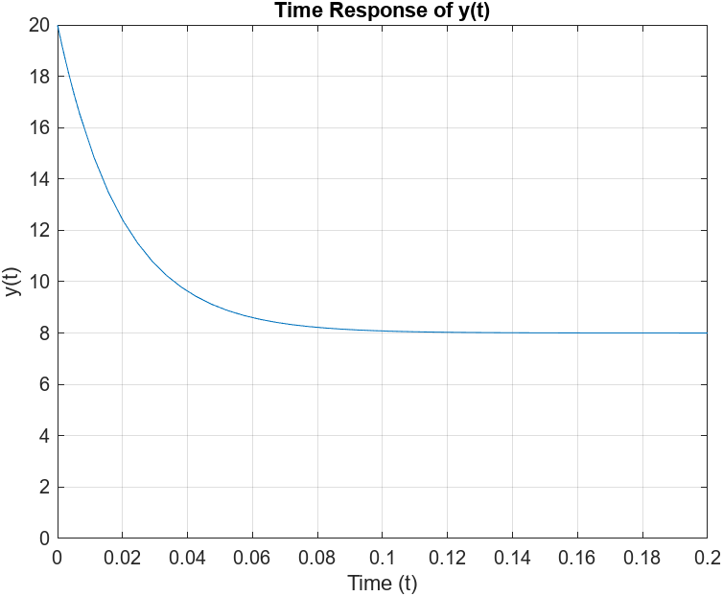

y_value_at_t = 19.4244

Problem 4:

% Define the differential equation

dydt = @(t, y) 400 * cos(75 * t) - 50 * y;

% Define the initial condition

y0 = 20;

% Define the time span

tspan = [0 1];

% Solve the differential equation

[t, y] = ode45(dydt, tspan, y0);

% Plot the time response

plot(t, y);

xlabel('Time (t)');

ylabel('y(t)');

title('Time Response of y(t)');

axis([0 1 -10 30]);

grid on;

% Find the value of y(t) for t = 0.5 sec

y_value_at_t = interp1(t, y, 0.5)

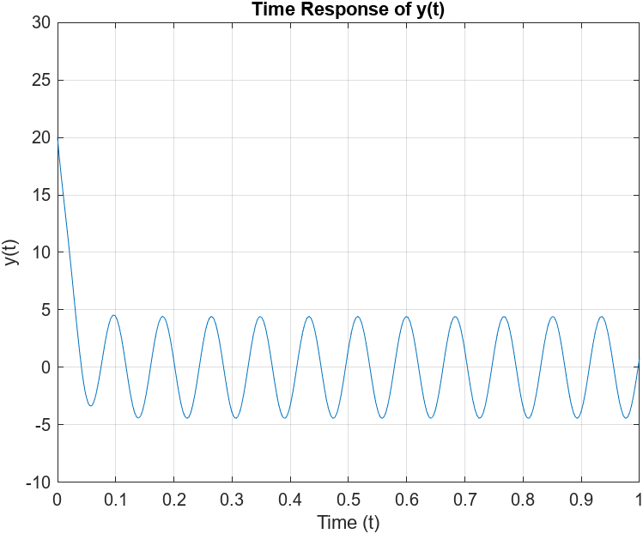

y_value_at_t = 1.6680

Problem 5:

% Define the differential equation

dydt1 = @(t, y, z) z;

dydt2 = @(t, y, z) -12 * y - 7 * z;

% Define the initial conditions

y0 = 20;

z0 = 0;

% Define the time span

tspan = [0 3];

% Solve the differential equation

[t, sol] = ode45(@(t, sol) [dydt1(t, sol(1), sol(2)); dydt2(t, sol(1), sol(2))], tspan, [y0, z0]);

% Extract the y(t) values

y = sol(:, 1);

% Plot the time response

plot(t, y);

xlabel('Time (t)');

ylabel('y(t)');

title('Time Response of y(t)');

axis([0 3 0 20]);

grid on;

% Find the value of y(t) for t = 0.5 sec

y_value_at_t = interp1(t, y, 0.5)

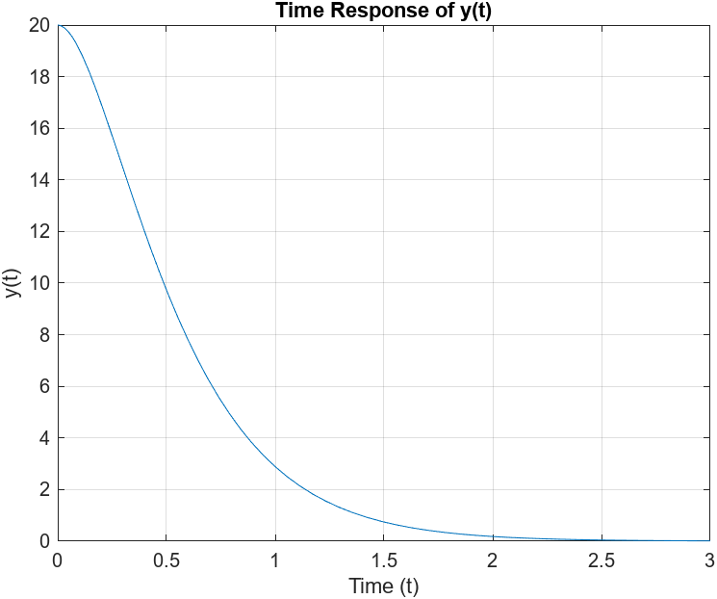

y_value_at_t = 9.7344

Problem 6:

% Define the differential equation

dydt1 = @(t, y, z) z;

dydt2 = @(t, y, z) 96 -12 * y - 7 * z;

% Define the initial conditions

y0 = 20;

z0 = 0;

% Define the time span

tspan = [0 3];

% Solve the differential equation

[t, sol] = ode45(@(t, sol) [dydt1(t, sol(1), sol(2)); dydt2(t, sol(1), sol(2))], tspan, [y0, z0]);

% Extract the y(t) values

y = sol(:, 1);

% Plot the time response

plot(t, y);

xlabel('Time (t)');

ylabel('y(t)');

title('Time Response of y(t)');

axis([0 3 0 20]);

grid on;

% Find the value of y(t) for t = 0.5 sec

y_value_at_t = interp1(t, y, 0.5)

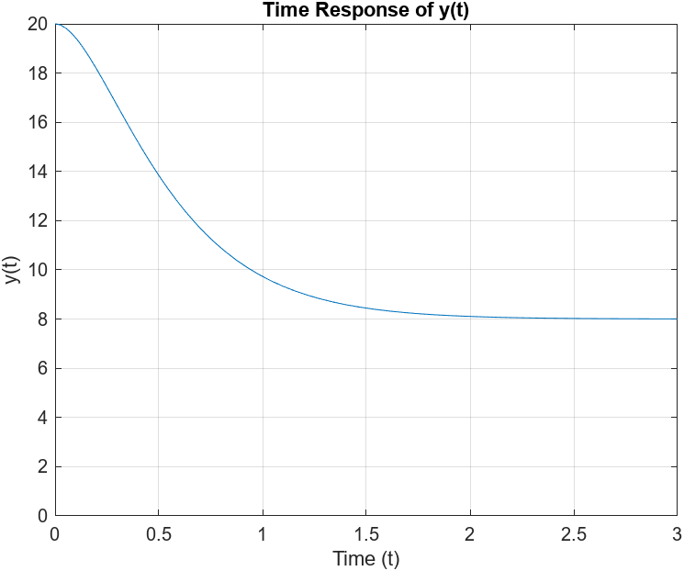

y_value_at_t = 13.8388

Problem 7:

% Define the differential equation

dydt1 = @(t, y, z) z;

dydt2 = @(t, y, z) 24 * exp(-4 * t) - 3 * z - 2 * y;

% Define the initial conditions

y0 = 10;

z0 = 5;

% Define the time span

tspan = [0 5];

% Solve the differential equation

[t, sol] = ode45(@(t, sol) [dydt1(t, sol(1), sol(2)); dydt2(t, sol(1), sol(2))], tspan, [y0, z0]);

% Extract the y(t) values

y = sol(:, 1);

% Plot the time response

plot(t, y);

xlabel('Time (t)');

ylabel('y(t)');

title('Time Response of y(t)');

axis([0 5 0 12]);

grid on;

% Find the value of y(t) for t = 1 sec

y_value_at_t = interp1(t, y, 1)

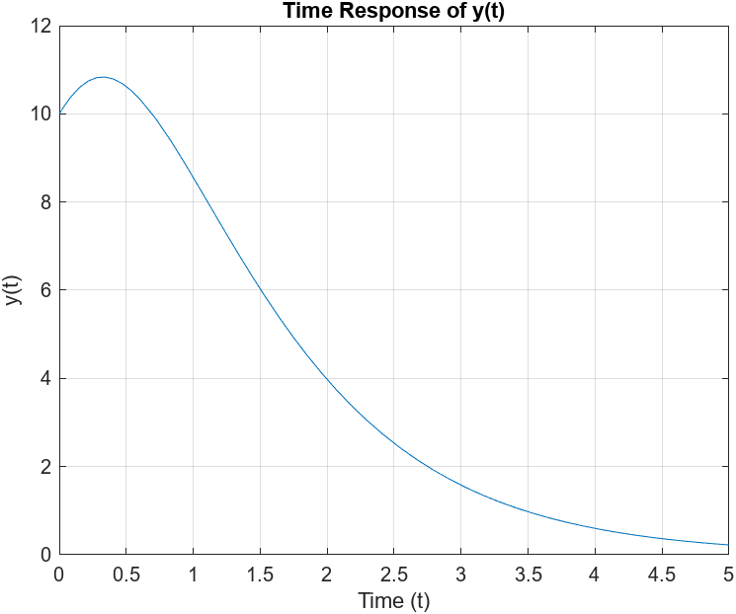

y_value_at_t = 8.5571

Problem 8:

% Define the differential equation

dydt1 = @(t, y, z) z;

dydt2 = @(t, y, z) 832 - 4 * z - 104 * y;

% Define the initial conditions

y0 = 0;

z0 = 0;

% Define the time span

tspan = [0 4];

% Solve the differential equation

[t, sol] = ode45(@(t, sol) [dydt1(t, sol(1), sol(2)); dydt2(t, sol(1), sol(2))], tspan, [y0, z0]);

% Extract the y(t) values

y = sol(:, 1);

% Plot the time response

plot(t, y);

xlabel('Time (t)');

ylabel('y(t)');

title('Time Response of y(t)');

axis([0 4 0 14]);

grid on;

% Find the value of y(t) for t = 1 sec

y_value_at_t = interp1(t, y, 1)

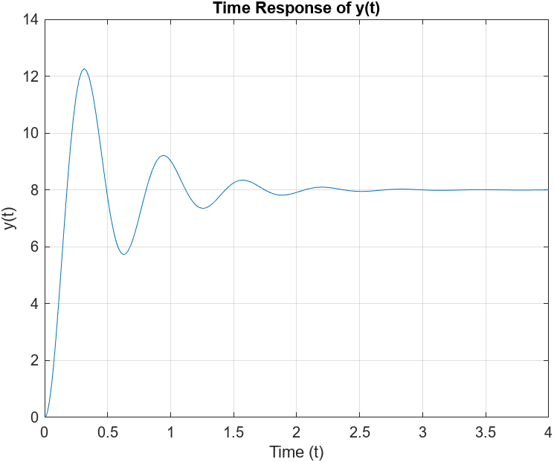

y_value_at_t = 9.0210